The Generation Law of Prime Numbers and the Proof of Goldbach's Conjecture

Gao Zhaohua
gaozhaohua@happymonkey.com.cn

Abstract：
This paper analyzes the definition of prime numbers from an evolutionary perspective by virtue of the relativistic thinking, and draws the conclusion that prime numbers are the set of factors for obtaining positive integers through the product iteration method. It also analyzes the physical significance and periodic laws in the generation process, and then proves Goldbach's Conjecture. The significance of this research lies in that analyzing prime numbers from an evolutionary perspective clarifies the relationship between prime numbers and integers more clearly, and integrates the thinking of mathematics with that of other disciplines at the ideological level. The proof of Goldbach's Conjecture also verifies this way of thinking, which can be popularized to facilitate the progress of more scientific research directions.
Keywords：
Evolution; Period; Relativistic Thinking; Distribution Law of Prime Numbers; Goldbach's Conjecture; Physical Metaphor; Lithography Machine Method; Progressive Tense
MR(2010):
11N05;11P32;03F60;00A30;

1 An Essential Understanding of the Definition of Prime Numbers
A prime number is defined as a natural number greater than 1 that has no positive divisors other than 1 and itself. From the perspective of relativistic thinking, a composite number (non-prime number) refers to a natural number greater than 1 that has at least two positive divisors other than 1 and itself. Therefore, any composite number can definitely be decomposed into the product of n prime numbers, and thus all natural numbers greater than 1 consist of prime numbers and the products of prime numbers.
Accordingly, all natural numbers greater than 1 can be constructed from 1 through product iteration.
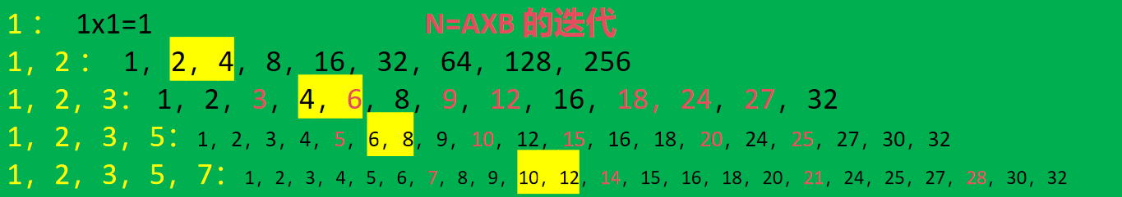
As shown in the table above, each time a new prime number is introduced, a series of natural numbers can be generated by multiplication with the newly introduced prime number, and the next prime number is derived simultaneously. The entire set of natural numbers greater than 1 is thus generated through such an iterative process.
From an evolutionary perspective, the understanding of prime numbers can be summarized as follows:
Prime numbers are the set of factors that yield all natural numbers greater than 1 through product iteration starting from 1.
This new formulation of the definition of prime numbers enables a clearer understanding of the relationship between prime numbers and positive integers, and also facilitates the grasp of their laws in the process of evolutionary growth.

2 Extended Imagination of the New Definition of Prime Numbers
Product iteration is a uniform periodic behavior, which can be metaphorically illustrated by the motion of "light". The generative process of prime numbers can be regarded as the emission of an infinite number of "light waves" with prime numbers as their wavelengths from the origin (0). The process of emitting these "light waves" forms the set of all natural numbers greater than 1, and the origin (0) is the only common intersection point of all prime numbers.
As shown in the figure below:

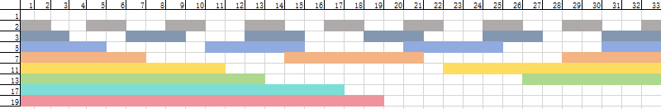
This is the physical significance of the generation of prime numbers.

3 Simplifying the Generation Model of Prime Numbers
Simplify the iterative process of prime number generation
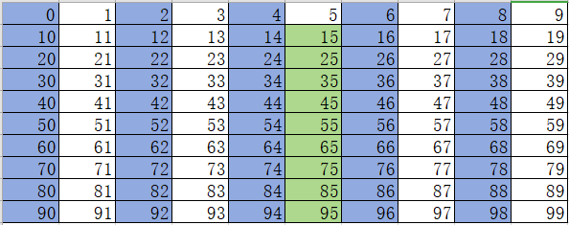
As shown in the above table, all even numbers are multiples of 2, and all natural numbers greater than 5 with a units digit of 5 are multiples of 5. Therefore, all prime numbers greater than 5 must exist among natural numbers greater than 5 whose units digits are 1, 3, 7, or 9.

It is self-evident that any even number can be expressed as the sum of two odd numbers a+b. If we remove all multiples of 5 from the set of odd numbers and denote the remaining set as A, the conclusion still holds that any even number can be expressed as the sum of two numbers in A. This is because if either a or b (or both) is a multiple of 5, we can convert them to a0​ and b0​ in set A through the operations of +2 and −2.

By removing the number 5 from set A, the simplified set becomes A1​={1,3,7,9}.
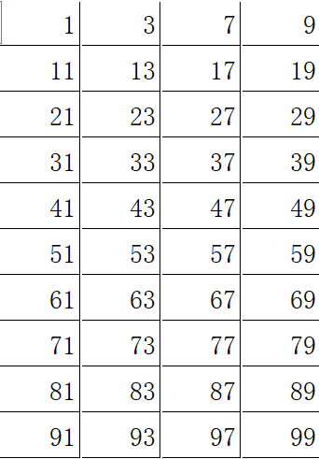
Similarly, the process of generating all natural numbers greater than 1 through product iteration can also be simplified to the process of generating set A1​, as shown in the figure below.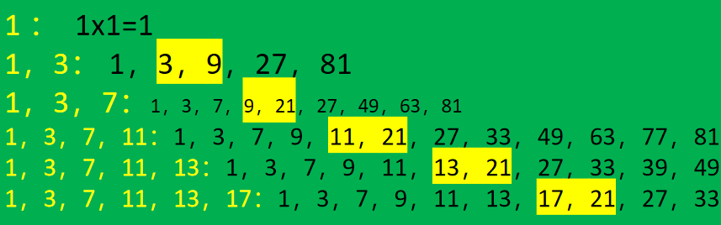
4 Generating Prime Numbers via the Lithography Method
From the perspective of relativistic thinking, the evolutionary generation of prime numbers can be analogized to the fabrication of microchips by a lithography machine: prime numbers can be "etched out" from set A1​. We start with set A1​ and perform layer-by-layer irradiation; the numbers hit by the irradiation are composite numbers (non-primes). This approach is defined as the lithography method for generating prime numbers.
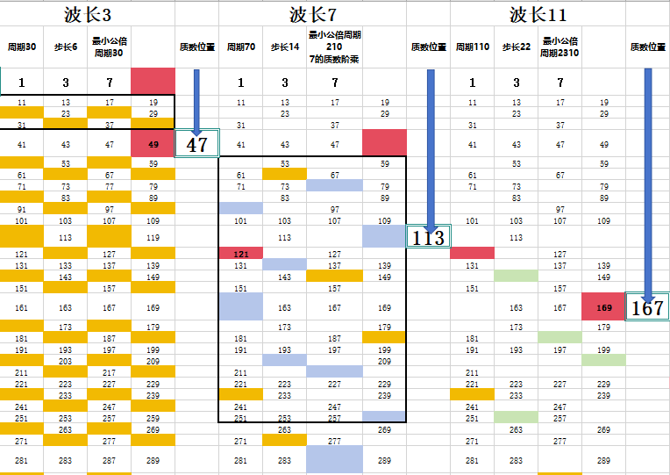
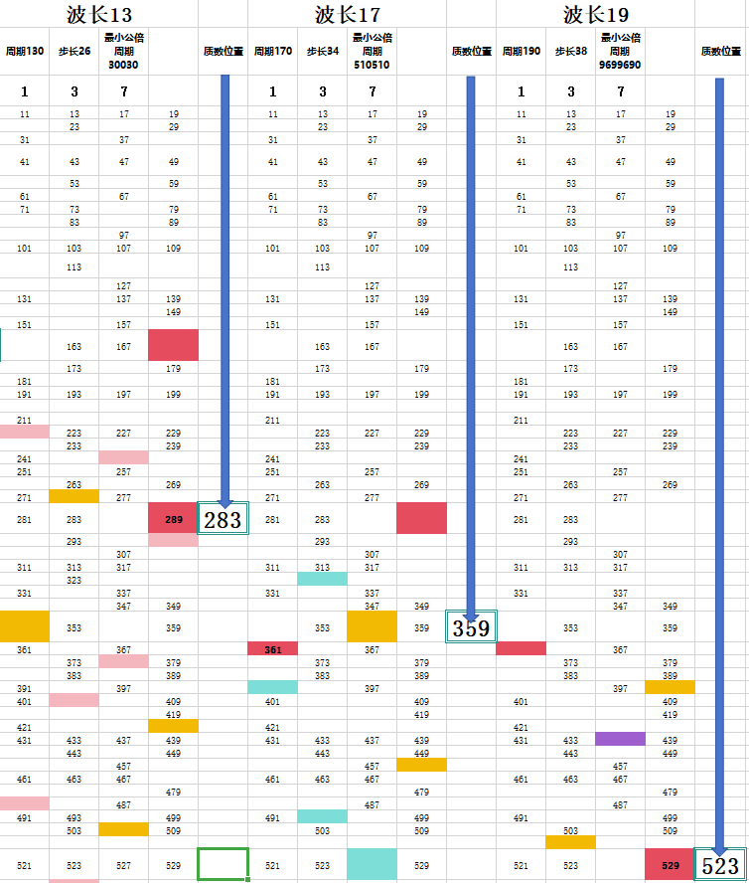
We analyze the periodic properties of prime number generation via the lithography method below. As shown in the above figure, the composite numbers hit by each layer of irradiation are marked with blocks of different colors. From the irradiation process, we draw the following conclusions:
- For the n-th irradiation with wavelength Kn​, the true prime numbers generated are all numbers up to the square of the wavelength of the next irradiation Kn+1​. Numbers greater than or equal to Kn+12​ are defined as provisional prime numbers relative to Kn​, which may or may not be hit by subsequent irradiations. Similarly, the irradiation with wavelength Kn​ only takes effect for numbers greater than or equal to Kn2​, as all smaller numbers have already been irradiated in previous steps.
- For the n-th irradiation with wavelength Kn​, the irradiation hits the units digits 1, 3, 7, 9 in a single cycle, with 4 hits per cycle.
- The set obtained by removing composite numbers hit by irradiation with wavelength 3 is denoted as A3​; by extension, the set obtained after irradiation with wavelength Kn​ is denoted as AKn​​.
- For the n-th irradiation with wavelength Kn​, the hit positions on set A1​ follow a fundamental period of Kn​×10 with a step size of Kn​×2.
- For the n-th irradiation with wavelength Kn​, overlapping hits occur with composite numbers marked by previous irradiations, and the overlapping positions correspond to the common multiples of the relevant wavelengths.
- After the n-th irradiation with wavelength Kn​, the overall hit distribution on set A1​ follows a least common period of 10× the product of all prime numbers up to Kn​, i.e., 10×Kn​×Kn−1​×Kn−2​×⋯×3. This is referred to as the least common multiple period after irradiation with wavelength Kn​.
- After the n-th irradiation with wavelength Kn​, the hit distribution relative to any previous wavelength Km​ (Km​<Kn​) on set A1​ follows a relative period of Kn​×Km​×10. In this relative period, there are exactly 4 overlapping hits of Kn​ and Km​, corresponding to the units digits 1, 3, 7, 9. By extension, for the hit distribution relative to multiple previous wavelengths Km​,Kh​,… (Km​,Kh​,⋯<Kn​), the relative period is 10×Kn​×Km​×Kh​×….
- Density variation of prime number distribution: The density of prime numbers between Kn2​ and Kn+12​ is determined by the irradiations with all prime wavelengths from 2 up to Kn​.
- There are infinitely many prime numbers. We can regard prime numbers as being in a continuous generative process, and thus their distribution always follows relative periodicity. Given the existence of such periodicity, the density distribution of prime numbers is convergent.

5 Several Deductions
- Since the lithography method for prime generation has a well-defined least common period, and prime numbers exist within this period, the assumption of a finite set of prime numbers would contradict the existence of the period. Therefore, there are infinitely many prime numbers.
- Based on the existence of the least common period in the lithographic generation of prime numbers, there are also infinitely many twin prime pairs.

6 Proof of Goldbach's Conjecture
To decompose an even number into the sum of two numbers from set A1​, we analyze even numbers by their units digits; each even number has two sets of digit combination solutions, as shown in the figure below.
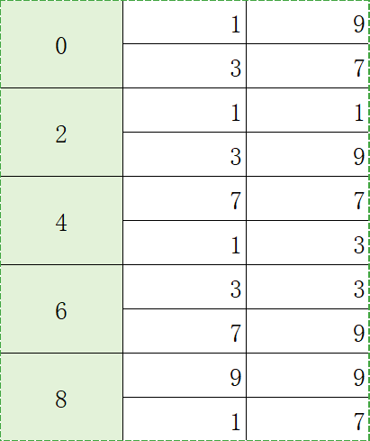
Example：
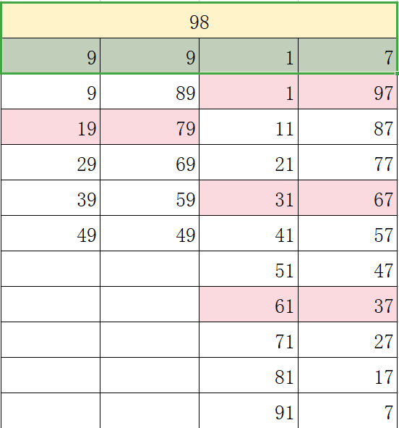
For the even number 98 (units digit 8), the valid units digit combinations are (9,9) and (1,7), with a total of 15 solution pairs. Among these, 3 pairs are prime number solutions, and 1 pair includes the number 1.
For any solution pair (a,b) in the set, adjacent solution pairs can be obtained by the operations (a+10,b−10) or (a−10,b+10). This property is defined as decimal solution symmetry.
This symmetry arises because set A1​={1,3,7,9} follows a fundamental period of 10 with a step size of 2, and its least common period is 10.
We first state Proposition X: For any even number p>12, p can be expressed as the sum of two numbers a+b from set A1​, and the number of such solution pairs is at least 1. Proposition X is obviously true.
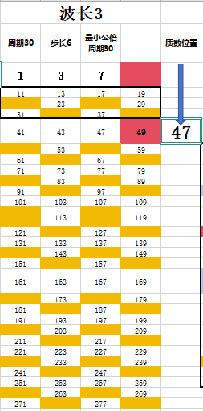
After irradiation with wavelength 3, we state Proposition X3: For any even number p>12, p can be expressed as the sum of two numbers from set A3​.
If irradiation with wavelength 3 does not hit all solution pairs of Proposition X, then X3 holds if X holds. Irradiation with the prime wavelength 3 follows a period of 30, hitting exactly one number with each of the units digits 1, 3, 7, 9 per period. Thus, the interval between two consecutive hits on numbers with the same units digit is 30.
Therefore, if a number a is hit by irradiation with 3, then a±10,a±20 are definitely not hit; and if a±30 are in set A1​ and greater than 10, they are definitely hit.
For any solution pair a+b satisfying X, if a, b, or both are hit by irradiation with 3, then exactly one pair among (a+10,b−10) and (a−10,b+10) is not hit; similarly, exactly one pair among (a+20,b−20) and (a−20,b+20) is not hit. Furthermore, non-hit solution pairs remain non-hit under the operations of +30 and −30.
Thus, Proposition X3 holds.
To prove Goldbach's Conjecture, it is sufficient to prove the general case: for any even number p<Kn+12​, after n times of irradiation, not all solution pairs of Proposition X are hit, and thus Proposition XKn​​ holds.
We have already proven that X holds for X3. For the general Proposition XKn​​, the proof is as follows:
- All prime numbers in the set of wavelengths Kn​ are mutually coprime, so their corresponding periods are also mutually coprime. If a solution pair (a,b) of X is hit by irradiation with Kn​: the irradiation with Kn​ follows a period of Kn​×10, while the solution pairs of X follow a fundamental period of 10. Thus, exactly one pair among (a+10,b−10) and (a−10,b+10) is not hit by Kn​. By extension, if a solution pair (a,b) of X3​ is hit by Kn​: the irradiation with Kn​ follows a period of Kn​×10, while the solution pairs of X3​ follow a period of 30. Thus, exactly one pair among (a+30,b−30) and (a−30,b+30) is not hit by Kn​. This conclusion can be generalized to all Xm​ (m<n).
- Assume XKn−1​​ holds but XKn​​ does not hold: this would require irradiation with Kn​ to hit all solution pairs of XKn−1​​. However, the relative common period of Kn​ and Kn−1​ has only 4 overlapping hit positions, corresponding to one hit for each units digit 1,3,7,9. Moreover, this relative period contains Kn​ periods of Kn−1​ (Kn​≥7). Combined with conclusion 1 above, irradiation with Kn​ cannot hit all solution pairs of XKn−1​​. The assumption is thus false.
- From the above reasoning, we conclude that for any even number p<Kn+12​, after n times of irradiation, not all solution pairs of X are hit, and XKn​​ holds for all n. This proves Goldbach's Conjecture.
- For further understanding: The growth of even numbers p is bounded by Kn+12​, while the range of irradiation that restricts prime solutions grows as Kn​×104×Kn+12​​. The gap between these two growth rates expands continuously. Additionally, attempting to hit all solution pairs (a,b) by superposing irradiations with multiple wavelengths Kn​ will exponentially expand the range of even numbers p and the set of (a,b), leading to a sharp decline in hit efficiency. Since irradiation with Kn​ only takes effect for numbers up to Kn+12​, there must always exist solution pairs of two prime numbers for any even number p.

7 Significance of the Research
Analyzing prime numbers from an evolutionary perspective clarifies the intrinsic relationship between prime numbers and integers with greater precision. This research also integrates the thinking of mathematics with that of other disciplines at the cognitive level, and the proof of Goldbach's Conjecture verifies the validity of this interdisciplinary thinking approach. The method can be further generalized to facilitate advancements in more scientific research fields.
All of the above conclusions stem from a deeper understanding of the fundamental nature of the world's operation: periodicity is the essence of existence. Here, periodicity is not merely a temporal concept, but refers to the stable and reproducible nature of all existing things—including the stable progression of time sequences, the stable topology of space, and the stable execution of natural laws. Periodicity has two core attributes:
- It maintains relative stability and possesses inertia, providing a fixed framework for the existence of all things;
- Its inherent imperfection generates the driving force for continuous iterative evolution.
The second attribute constantly creates and destroys the first in the process of motion, while the first attribute provides a relatively stable foundation and a moderate resistance to the second. This dynamic interaction enables the cycle of metabolism and sustains the endless evolution of all things in the universe.

